SPRINGBOARD

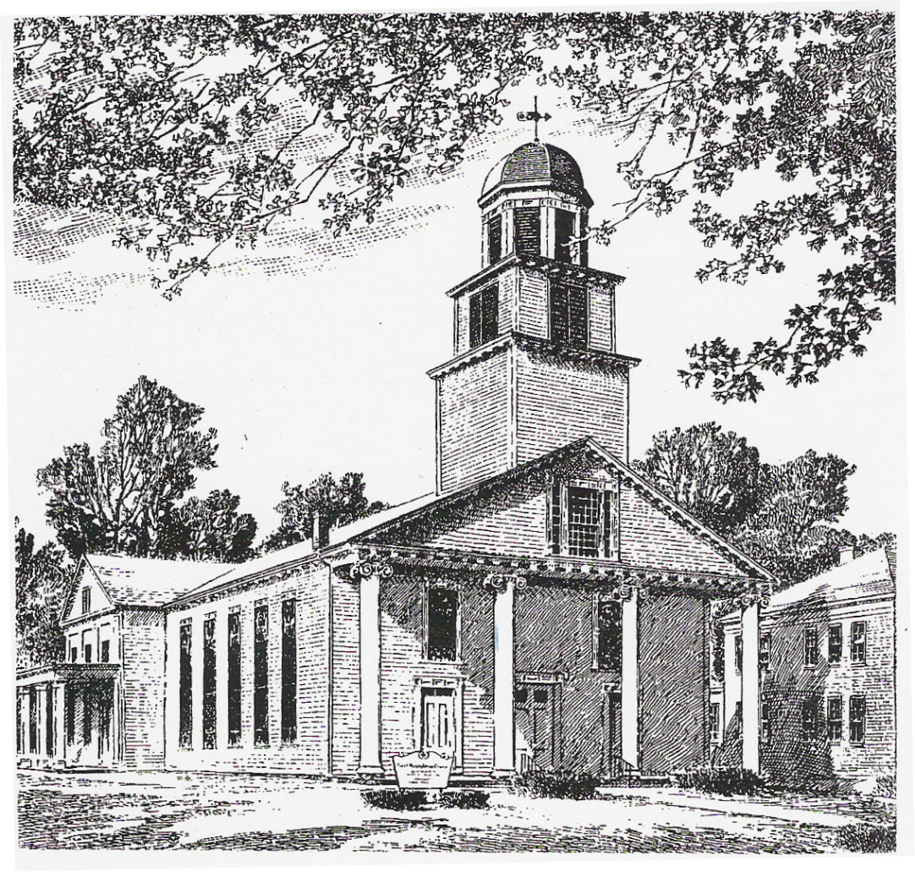

March 2020 – April 2020

News and Events of Interest for Members and Friends of the

First Presbyterian Church

Montgomery, NY



FPC Montgomery,

I am a little slow getting the Springboard out so I beg your forgiveness. But I have to spend my time here to say how proud I am of all you all have accomplished; or better stated….that God has accomplished through you all.

We have had a great deal of work being done in all aspects of the church: from people working hard to prepare reports, financial statements, doing nominations (and those willing to be nominated) as we moved toward our Annual Meeting; to those who worked hard behind the scenes to help gather and decide a way ahead in regard to the “rediscovered” annuities and savings account; to working to help bring the facilities into compliance for new licensing for the Montgomery Nursery School (including installing a Fire Detection System); to a massive Gold Award Project to repair the sanctuary ceiling and the bold decision to have the walls and everything done at the same time (and all the quick adjustments that were made in the process).

That doesn’t even cover the other “normal” things that took place from meetings, choir practices, worship preparation, cleaning, Sunday school leadership/teaching, and so, so much more. I know the danger when you attempt to list what went on in that you will miss things that are extremely important….so accept my apologies if I did.

All of this….every last bit of it, would not be possible without the work and dedication of all of you. I have to add that in all of these things there is always welcomed and needed helping hands. For the simple truth is that these things I talked about are done through the donation of your resources (your tithes, your time, and your talents). I say thank you because these are all fruits of God’s work in all of you.

Humbly,

Pastor Jeromey

CONTINUED SERMON SERIES

Pastor Jeromey will be continuing a 12-week Sermon Series on the Apostles’ Creed that started on the 19th of January and will conclude on Palm/Passion Sunday. It will go through each theological statement contained in the creed; exploring meaning and context. We hope you will be able to join us as we explore what it is we say together each time we observe one of the sacraments in worship.

# UPDATES

If you find yourself as one of those who do not know what is going on around the church at times there are three ways to get information that can help. The first is the one I know everyone knows about….Sunday morning and the bulletin. The second is that Pastor Jeromey sends out occasional emails with information about things that are going on or upcoming. If you are not getting those and would like to just email him as [pastorjeromey@gmail.com](mailto:pastorjeromey@gmail.com) and he will add you to the email list. The third way is that we try to make sure all updates or events are posted on Facebook and the church calendar. The hope is with these three methods adequate information is available.

FOOD PANTRY

Thank you to everyone for your generous donations during the Souper Bowl of Caring! All the cans of soup you donated have been brought to the Food Pantry and are being used to help those in their time of need.

First Presbyterian Church staffs the pantry again in May. Volunteers are always needed! Pantry hours are Tuesdays, 10:00 a.m. to noon, and Wednesdays, 6:30 to 8:00 p.m. If you can help, please call Pastor Jeromey @ 500-1319.

PRAYER SHAWL GROUP

Your prayer shawl group meets the second Sunday of each month in Fellowship Hall after worship. If you would like to know more about the group, please contact a deacon for more information. Training and supplies are available for anyone willing to learn.

UPDATED MEMBERSHIP LIST

A new membership list is available. As always if your address or telephone number has changed, ***please*** call the church office (457-5383) and leave a message with the correct information. Thanks!

LENTEN STUDY

A Lenten Study will continue using the book “Entering the Passion of Jesus” written by Amy-Jill Levine. Each study will take place at 1PM on Sundays in the Fellowship Hall. We hope to see you there.

HOLY WEEK/EASTER SCHEDULE

Maundy Thursday Service – 7 PM

Good Friday Service – 7 PM

Easter Sunrise Service (Pleasure Ground Park Pavilion) – 6:15 AM

Potluck Breakfast and Intergenerational Craft – 9:30 AM

Easter Worship Service – 11 AM

PASTOR EMERITUS CELEBRATION

Our celebration of having the Reverend Paul M. Milz designated as our Pastor Emeritus will be May 2 – 3. Dinner on May 2nd will be at the Montgomery Senior Center from 5 to 9 p.m. Reservations are required and specific information on that will be out shortly!

Many thanks to all who have been donating to help offset costs – commemorating plaque, rent of senior center, lowering cost of dinner, flowers, etc. What a help!

March 2020

Mar 1, Sun. 9:00 a.m. Junior Chorus

9:30 a.m. Sunday School

11:00 a.m. Worship – Sacrament of the Lord’s Supper

Noon Board of Deacons

1:00 p.m. Lenten Study – Fellowship Hall

Mar 2, Mon. 7:30 p.m. Westminster Guild

Mar 5, Thurs. 7:00 p.m. Choir rehearsal

Mar 8, Sun. 9:00 a.m. Junior Chorus

9:30 a.m. Sunday School

11:00 a.m. Worship

Noon Prayer Shawl Group

1:00 p.m. Lenten Study – Fellowship Hall

Mar 12,Thurs. 7:00 p.m. Choir rehearsal

Mar 15, Sun. 9:00 a.m. Junior Chorus

9:30 a.m. Sunday School

11:00 a.m. Worship

1:00 p.m. Lenten Study – Fellowship Hall

Mar 17, Tues. 7:00 p.m. Session

Mar 19, Thurs. 7:00 p.m. Choir rehearsal

Mar 22, Sun. 9:00 a.m. Junior Chorus

9:30 a.m. Sunday School

11:00 a.m. Worship

1:00 p.m. Lenten Study – Fellowship Hall

Mar 26, Thurs. 7:00 p.m. Choir rehearsal

Mar 29, Sun. 9:00 a.m. Junior Chorus

9:30 a.m. Sunday School

11:00 a.m. Worship

Noon Coffee and Conversation

1:00 p.m. Lenten Study – Fellowship Hall

******************************************************************************************

* *SPECIAL DAYS* *

* *

* *Birthdays* *

* Emily Adams – March 2 Marlene Wood – April 7 *

* Marcia Neubauer – March 3 Frank Pettine – April 10 *

* Ross Benedict – March 5 Casey Adams – April 12 *

* Laura Aiello – March 9 Cheryl Conero – April 15 *

* Henry Goldberg – March 13 Kimberly Neubauer – April 15 *

* Nikki Conero – March 14 Victoria Arnott – April 18 *

* Mary Prior – March 15 Allison Conero – April 24 *

* Marcus Mosenson – March 30 Heather Conley – April 29 *

* Emma Jardine – March 31 Donna Flannery – April 30 *

* *

******************************************************************************************

April 2020

April 5, Sun. PALM/PASSION SUNDAY

9:00 a.m. Junior Choir

9:30 a.m. Sunday School

11:00 a.m. Worship – Sacrament of the Lord’s Supper

Noon Deacons’ meeting

1:00 p.m. Lenten Study – Fellowship Hall

April 9, Thurs. 7:00 p.m. Maundy Thursday Service

April 10, Fri. 7:00 p.m. Good Friday Service

April 11, Sun. EASTER SUNDAY – No Sunday School

6:15 a.m. Sunrise Service – Pleasure Ground Park Pavilion

9:30 a.m. Potluck Breakfast/Intergenerational Craft

11:00 a.m. Worship

Noon Prayer Shawl Group

\*\*\*\*\*\*\*\***DEADLINE FOR *SPRINGBOARD* ARTICLES \*\*\*\*\*\*\*\***

April 16, Thurs. 7:00 p.m. Choir rehearsal

7:00 p.m. Oyster Supper set-up

April 17, Fri. various Oyster Supper preparations

April 18, Sat. 7:00 a.m. start Oyster Supper preparations and event

April 19, Sun. 9:00 a.m. Junior Choir

9:30 a.m. Sunday School

11:00 a.m. Worship

April 21, Tues. 7:00 p.m. Session

April 23, Thurs. 7:00 p.m. Choir rehearsal

April 26, Sun. 9:00 a.m. Junior Choir

9:30 a.m. Sunday School

11:00 a.m. Worship – followed by Coffee & Conversation

CHANCEL FLOWERS

Anyone wishing to have flowers in church any time this year is asked to let our **new** Floral Secretaries know. Arlene Geiger & Carolyn Henrie will be taking orders for chancel flowers, Easter lilies, and Mother’s & Father’s Day and poinsettia plants.

The cost of chancel flowers will be $8.00 and the others will be $13.00. Also, please let the Floral Secretary or the Church Secretary know of a birth of a child or grandchild in your family so this special occasion can be honored with a rose. This is a sponsored item and no cost to the family.

If you would like to have chancel flowers either as a memorial or special occasion, please print and fill out this from and give it to Arlene or Carolyn, or you can leave it in the church office.

Checks should be made out to:

FIRST PRESBYTERIAN CHURCH FLOWER FUND

Your support of our church’s floral ministry is very much appreciated.

Arlene & Carolyn

ORDER FORM FOR CHANCEL FLOWERS

The cost is $8.00.

Date you wish to sponsor flowers___________________________________

Donated by____________________________________________________

Wording (memory of/honor of)_____________________________________

_____________________________________________________________

Date you wish to sponsor flowers___________________________________

Donated by____________________________________________________

Wording_______________________________________________________

( ) I would like to sponsor and Easter lily ($13.00)

Wording_______________________________________________________

( ) I would like to sponsor a Mother’s Day plant ($13.00)

Wording_______________________________________________________

( ) I would like to sponsor a Father’s Day plant ($13.00)

Wording_______________________________________________________

( ) I would like to sponsor a Poinsettia ($13.00)

Wording_______________________________________________________

This is a list of church officers. Please refer to your membership list for telephone numbers.

Pastor – Rev. Jeromey Howard

Clerk of Session – Heather Benedict

SESSION (RULING Elders)

*Class of 2021 Class of 2022 Class of 2023*

Beth Hoeffner Heather Benedict Carl Van Dyke

Cynthia Nokland Carol Jellema Robin McPhillips

Mary Pettine John Nokland Joe Prior Sr.

BOARD OF DEACONS

*Class of 2021 Class of 2022 Class of 2023*

Joanne Toombs Shawn Arnott Donna Powles

Kim Hoeffner Beth Kehoe Kirsten Howard

Emil Pignetti Karla Ritter Debbie Fagan

SESSION COMMITTEE CHAIRPERSONS – TBD – Left as is for now

Buildings & Grounds Joe Prior & John Nokland

Membership Development Cynthia Nokland & Mary Pettine

Nominating Committee

Personnel Committee Mary Pettine

Christian Education Beth Hoeffner

Stewardship & Budget Committee Heather Benedict

Worship Committee Carol Jellema

Mission Committee Beth Hoeffner, Joe Prior, & Heather Benedict

CHURCH STAFF

Office Secretary Carol Jellema

Church Treasurer Taylor Raimondo

Financial Secretary Heather Ross Benedict

Organist/Choir Director Marcia Woodall

Floral Secretaries Arlene Geiger & Carolyn Henrie

Custodian Abigail Nokland

Westminster Guild President Cynthia Nokland

Sunday School Officers Tom McNutt ~ Superintendent

Janis Guaragno ~ Treasurer

The church office hours are Thursday and Friday, from 9:00 a.m. to 1:00 p.m.

The office phone number is 845-457-5383, the fax number is 845-457-7055, and our email is [fpcmont137@frontiernet.net](mailto:fpcmont137@frontiernet.net). Visit our website at fpcmontgomery.com.

For Pastor Jeromey email [pastorjeromey@gmail.com](mailto:pastorjeromey@gmail.com) or for immediate needs call his cell at 845-500-1319

The church’s mailing address is: First Presbyterian Church

137 Clinton Street

Montgomery, NY 12549