SPRINGBOARD

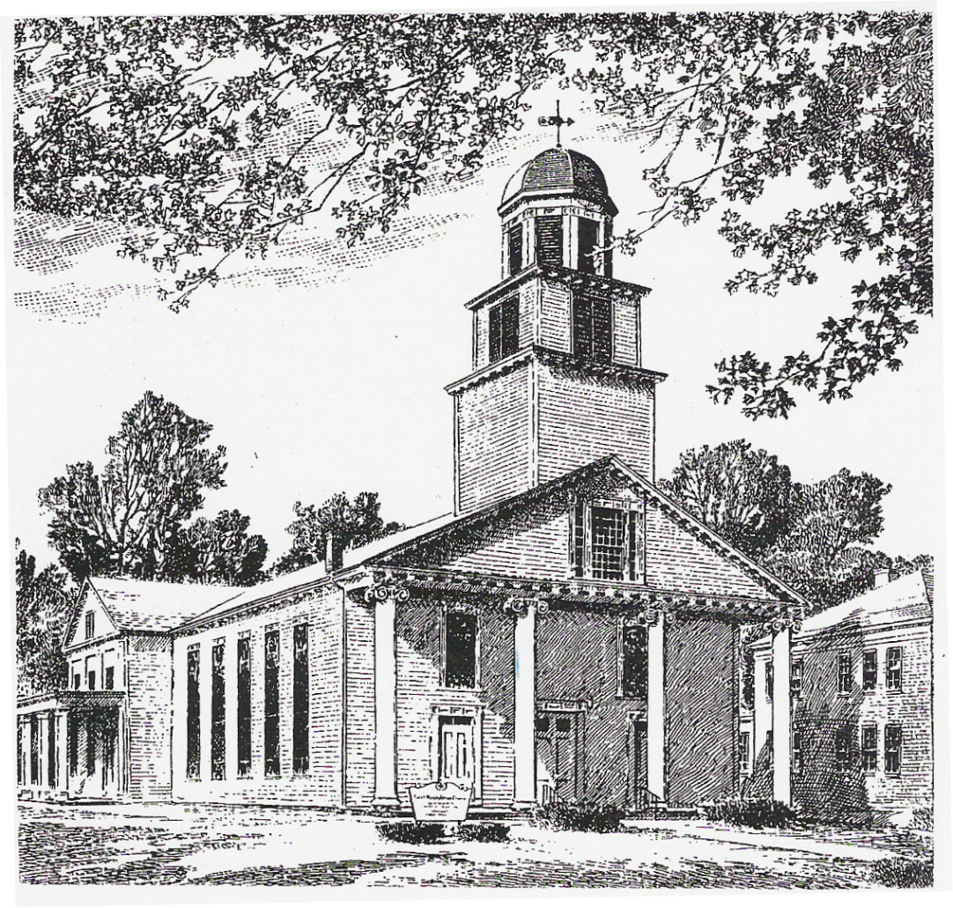

January 2020 – February 2020

News and Events of Interest for Members and Friends of the

First Presbyterian Church

Montgomery, NY



FPC Montgomery,

I hope this finds you starting off with a great New Year. We had a full and meaningful 2019 and we are now turning our attention to all that the New Year, 2020, will hold. To start off the New Year the PCUSA offered a prayer from the Common Book of Worship I will share with you now:

**Eternal God, a thousand years in your sight are like a watch in the night. As you have led us in the days past, so guide us now and always, that our hearts may learn to choose your will, and new resolves be strengthened; through Jesus Christ our Lord, Who lives and reigns with you in the unity of the Holy Spirit, One God, Now and Forever. Amen.**

In the coming year I know we will be doing a lot but to be fully honest nobody knows what all we will be called to do. From opportunities to see the work of a Girl Scout Gold Award Project completed with repairs to the sanctuary ceiling, to buildings and grounds folk working hard to keep up the building, to Sunday School classes and programs, to other classes, to food pantry volunteering, to taking care of each other in our moments of need, to a never ending list of what is in front of us.

I am thankful to have the opportunity to be part of this Family of Faith and I am overjoyed that I have gotten to know you and will continue to in the days and years ahead. Thank you for all that you do as part of God’s ministry here, for it is each and every one of you who help make what we do possible.

Humbly,

Pastor Jeromey

UPCOMING SERMON SERIES

Pastor Jeromey will be starting a 12 week Sermon Series on the Apostles Creed starting on the 19th of January. It will go through each theological statement contained in the Creed; exploring meaning and context. We hope you will be able to join us as we explore what it is we say together each time we observe one of the Sacraments in Worship.

# Dear Family of Faith,

# A while back Hudson River Presbytery took up the call to look at the various ways in which we are called to be good stewards of the divinely created natural earth upon which we live and are a part of. One of the ways they have responded to this call is to prohibit the use of plastic bottles at any of the gatherings of Hudson River Presbytery and they have called upon the congregations to consider doing the same.

# After much thought and discussion by your Session, we have decided to make the effort to avoid using plastic bottles as part of our ministry to the fullest extent reasonable. When a function is planned and held, one of the roles we will take up is reminding those planning it to make every effort where possible to not use plastic bottles. On this same note we realize that at times this may be the only reasonable option.

# We have also decided that we will strive to keep and pay attention to how and what we use and the impact it may have on the environment (both in production and disposal). So as we use up the supplies of items we currently already have in storage at the church, we will then be aware of environmental concerns as we purchase any new products.

# We encourage every family to take up this same call. The call is to face the simple truth that throughout our time on this earth we can either choose to take actions which do harm to God’s creation or not. It is part of our calling to do the least amount of harm or damage we can. We hope you will join us in this effort to be the best stewards that we can be.

# Yours sincerely,

# The Session of First Presbyterian Church of Montgomery

# PLEDGE UPDATE

To date we have received 34 pledges for 2020, totaling $85,672 toward the work of the Body of Christ. If you have not yet returned your pledge card, please do so! It is not too late!

FOOD PANTRY

The Town of Montgomery Food Pantry thanks you for your very thoughtful and generous donations to the food pantry. Your contributions are extremely appreciated, welcomed, and, of course, needed. Consistent food supplies are something we can’t always rely on. Your donations were very helpful both during the holiday season and again afterwards. The food pantry typically serves about 200 families each month. This includes approximately 200 children, 275 adults and 80 senior citizens. It is important that the people in our local community can depend on being able to get food when they need it. We surely couldn’t do it without your help!

First Presbyterian Church staffs the pantry again in May. Volunteers are always needed! Pantry hours are Tuesdays, 10:00 a.m. to noon, and Wednesdays, 6:30 to 8:00 p.m. If you can help, please call Pastor Jeromey @ 500-1319.

# WESTMINSTER GUILD

Thank you to all the ladies who baked for the annual cookie exchange.

We have no meeting in the months of January and February. Please join us again on March 2nd. We meet the first Monday of the month at 7:30 pm. except for June and October when we meet at 6:30 pm and begin with a covered dish supper!

PRAYER SHAWL GROUP

Your prayer shawl group meets the second Sunday of each month in Fellowship Hall after worship. If you would like to know more about the group, please contact a deacon for more information. Training and supplies are available for anyone willing to learn.

CHANGES

A new membership list will be available at the annual meeting on February 9th. If your address or telephone number has changed in the past year, ***please*** call the church office (457-5383) and leave a message with the correct information. Thanks!

# NOMINATING COMMITTEE

The Nominating Committee is diligently working to consider the particular gifts of our members and who among us God may be calling to serve the Church as Elder or Deacon. Our Deacons and Elders play an integral part in the leadership and witness of our church. Please keep the committee in your prayers as we seek to do this work with sincerity and faithfulness to God. A form for nominations is elsewhere in this newsletter.

ANNUAL CONGREGATIONAL MEETING

Session has called for the 185th Annual Congregational Meeting of First Presbyterian Church to be held on Sunday, **February 9, 2020**, in the sanctuary following worship. The purpose of the meeting is to elect officers, receive reports from the treasurer and various organizations of the church, act on pastoral compensation, and consider any other business that may properly come before the congregation.

ASH WEDNESDAY

Please join us on February 26th at 7 p.m. for our Ash Wednesday Service of Healing.



JANUARY 2020

Jan. 2, Thurs. 7:00 p.m. Choir rehearsal

Jan. 5, Sun. 9:00 a.m. Junior Chorus

9:30 a.m. Sunday School

11:00 a.m. Worship – Sacrament of the Lord’s Supper

Noon Board of Deacons

Jan. 6, Mon. Epiphany of the Lord

Jan. 9, Thurs. 7:00 p.m. Choir rehearsal

Jan. 12, Sun. Baptism of the Lord

9:00 a.m. Junior Chorus

9:30 a.m. Sunday School

11:00 a.m. Worship

Noon Prayer Shawl Group

Jan.16,Thurs. 7:00 p.m. Choir rehearsal

Jan. 19, Sun. 9:00 a.m. Junior Chorus

9:30 a.m. Sunday School

11:00 a.m. Worship

Jan.21, Tues. 7:00 p.m. Session

Jan. 23, Thurs. 7:00 p.m. Choir rehearsal

Jan. 26, Sun. 9:00 a.m. Junior Chorus

9:30 a.m. Sunday School

11:00 a.m. Worship ~ followed by Coffee & Conversation



FEBRUARY 2020

Feb. 2, Sun. 9:00 a.m. Junior Choir

9:30 a.m. Sunday School

11:00 a.m. Worship – Sacrament of the Lord’s Supper

Noon New Officer Training

Deacons’ meeting

Feb. 6, Thurs. 7:00 p.m. Choir rehearsal

Feb. 9, Sun. 9:00 a.m. Junior Choir

9:30 a.m. Sunday School

11:00 a.m. Worship

Noon Annual Congregational Meeting in the sanctuary

\*\*\*\*\*\*\*\***DEADLINE FOR *SPRINGBOARD* ARTICLES \*\*\*\*\*\*\*\***

Feb. 13, Thurs. 7:00 p.m. Choir rehearsal

Feb. 16, Sun. 9:00 a.m. Junior Choir

9:30 a.m. Sunday School

11:00 a.m. Worship – Ordination & Installation of Church Officers

Feb. 18, Tues. 7:00 p.m. Session

Feb. 20, Thurs. 7:00 p.m. Choir rehearsal

Feb. 23, Sun. 9:00 a.m. Junior Choir

9:30 a.m. Sunday School

11:00 a.m. Worship – followed by Coffee & Conversation

Feb. 26, Wed. 7:00 p.m. Ash Wednesday Service

*****************************************************************************************************

* SPECIAL DAYS *

* *

* Birthdays *

* Courtney Pettine – January 10 Stuart Goldberg – January 28 *

* Charles Sweet – January 11 Daniel Marvin – January 30 * * Joe Prior – January 11 Frank Shaskan – January 31 *

* Paige Adams – January 12 Isabelle Nokland – January 31 *

* Kathy Birch – January 12 Debbie Richards – February 1 *

* Max Neubauer – January 12 Arianna Mosenson – February 4 *

* Lilia Flannery – January 12 Kristi Kramer – February 8 *

* Jason Marvin – January 20 Brittany Garretto – February 12 *

* Michael Guaragno – January 20 Joseph DeVenuto – February 18 *

* Kelley Honkala – January 23 *

* *

******************************************************************************************************

NOMINATIONS FOR CHURCH OFFICERS

Please use the bottom of this page to make nominations. The following descriptions might help you.

**\*\*ELDERS**: "Elders should be persons of faith, dedication, and good judgment. Their manner of life should be a demonstration of the Christian gospel, both within the church and within the world. It is the duty of Elders, individually and jointly, to strengthen and nurture the faith and life of the congregation committed to their charge. Together with the pastor, they should encourage the people in worship and service of God, equip and renew them for their tasks within the church and for their mission in the world, visit and comfort and care for the people, with special attention to the poor, the sick, the lonely, and those who are oppressed.

"Those duties which all Christians are bound to perform by the law of love are especially incumbent upon Elders because of their calling to office, and are to be fulfilled by them as official responsibilities."

**\*\*DEACONS**: "The office of Deacon as set forth in scripture is one of sympathy, witness, and service after the example of Jesus Christ. Persons of spiritual character, honest repute, exemplary lives, brotherly and sisterly love, warm sympathies, and sound judgment should be chosen for this office.

"It is the duty of Deacons first of all to minister to those who are in need, to the sick, to the friendless, and to any who are in distress."

***Please note: All persons on the Active Roll of the church are eligible for nomination and election to church office (unless he or she has served 6 consecutive years in that office). There are no age requirements for Elders or Deacons, and no one, if he or she be a person of good faith, is 'too new' or 'too old' a member to serve Christ well in the church.

-------------------------------------------------------------------------------------------------------------------------------

Note: As you consider persons who might serve as elders, deacons, or trustees, the nominating committee asks that you please keep the following in mind:

1. the present level of involvement in the life of the church. For example: regular attendance at worship, participation in other church activities, present or past offices held, special services rendered, or special qualifications for office.

2. the evidences of personal commitment to Jesus Christ, and Christian living in daily life; the person's compassion and concern for others.

3. personal characteristics and skills that would be important for officers, such as: an ability to cooperate with others, a willingness to learn, an openness to new ideas, personal creativity, maturity of judgment, follow-through on assignments, and being one who would give of himself or herself fully in his or her work as elder, deacon, or trustee.

-------------------------------------------------------------------------------------------------------------------------------

If you have a name (or names) to suggest, please return this form in a sealed envelope to the church as soon as possible. You may leave the envelope, marked to the attention of the nominating committee, in the offering plate. If this is not convenient, you may mail it to: First Presbyterian Church, Attn: Nominating Committee, 100 Union Street, Montgomery, NY 12549.

NOMINATIONS FOR CHURCH OFFICERS

I suggest the name of _______________________________________

for nomination as Elder ________ Deacon ________

Signed (optional) __________________________________________

The name of the person making the suggestion may be helpful, but is not necessary. Self-nominations are also encouraged, and are welcomed.

CHANCEL FLOWERS

Anyone wishing to have flowers in church any time this year is asked to let our **new** Floral Secretaries know. Arlene Geiger & Carolyn Henrie will be taking orders for chancel flowers, Easter lilies, and Mother’s & Father’s Day and poinsettia plants.

The cost of chancel flowers will be $8.00 and the others will be $13.00. Also, please let the Floral Secretary or the Church Secretary know of a birth of a child or grandchild in your family so this special occasion can be honored with a rose. This is a sponsored item and no cost to the family.

If you would like to have chancel flowers either as a memorial or special occasion, please print and fill out this from and give it to Arlene or Carolyn, or you can leave it in the church office.

Checks should be made out to:

FIRST PRESBYTERIAN CHURCH FLOWER FUND

Your support of our church’s floral ministry is very much appreciated.

Arlene & Carolyn

ORDER FORM FOR CHANCEL FLOWERS

The cost is $8.00.

Date you wish to sponsor flowers___________________________________

Donated by____________________________________________________

Wording (memory of/honor of)_____________________________________

_____________________________________________________________

Date you wish to sponsor flowers___________________________________

Donated by____________________________________________________

Wording_______________________________________________________

( ) I would like to sponsor and Easter lily ($13.00)

Wording_______________________________________________________

( ) I would like to sponsor a Mother’s Day plant ($13.00)

Wording_______________________________________________________

( ) I would like to sponsor a Father’s Day plant ($13.00)

Wording_______________________________________________________

( ) I would like to sponsor a Poinsettia ($13.00)

Wording_______________________________________________________

This is a list of church officers. Please refer to your membership list for telephone numbers.

Pastor – Rev. Jeromey Howard

Clerk of Session – Heather Benedict

SESSION (RULING Elders)

*Class of 2020 Class of 2021 Class of 2022*

Robin Long-DeAngelo Beth Hoeffner Heather Benedict

Tom McNutt Cynthia Nokland Carol Jellema

Joseph Prior Mary Pettine John Nokland

BOARD OF DEACONS

*Class of 2020 Class of 2021 Class of 2022*

Shawn Arnott

Donna Flannery Kim Hoeffner Beth Kehoe

Mary Tindell Emil Pignetti Karla Ritter

SESSION COMMITTEE CHAIRPERSONS

Buildings & Grounds Joe Prior & John Nokland

Membership Development Cynthia Nokland & Mary Pettine

Nominating Committee Robin Long-DeAngelo

Personnel Committee Mary Pettine

Christian Education Tom McNutt & Beth Hoeffner

Stewardship & Budget Committee Heather Benedict

Worship Committee Carol Jellema

Mission Committee Beth Hoeffner, Joe Prior, & Heather Benedict

CHURCH STAFF

Office Secretary Carol Jellema

Church Treasurer Taylor Raimondo

Financial Secretary Heather Ross Benedict

Organist/Choir Director Marcia Woodall

Floral Secretaries Arlene Geiger & Carolyn Henrie

Custodian Abigail Nokland

Westminster Guild President Cynthia Nokland

Sunday School Officers Tom McNutt ~ Superintendent

Janis Guaragno ~ Treasurer

The church office hours are Thursday and Friday, from 9:00 a.m. to 1:00 p.m.

The office phone number is 845-457-5383, the fax number is 845-457-7055, and our email is [fpcmont137@frontiernet.net](mailto:fpcmont137@frontiernet.net). Visit our website at fpcmontgomery.com.

The church’s mailing address is: First Presbyterian Church

100 Union Street

Montgomery, NY 12549